DML Commands – INSERT, SELECT

AIM:

To perform Data Manipulation Language (DML) Commands such as INSERT, SELECT in the table.

Description:

Data Manipulation Language (DML) statements are used for managing data within schema objects. DML Commands: Insert, Select
- INSERT - insert data into a table
- SELECT - retrieve data from the a database

INSERT:

INSERT INTO table_name
VALUES (value1, value2, value3, ...); (or)

INSERT INTO table_name (column1, column2, column3, ...)
VALUES (value1, value2, value3, ...);
SELECT:
SELECT column_name(s)
FROM table_name;

Questions:
1.Populate all the five tables with your own data.
INSERT INTO juiceshopc
(customer_name, token_no, juice_name, payment_mode, shop_location, no_of_juices)
VALUES
('G.Chakri', 321, 'Mango', 'UPI', 'Tirupathi', 3),
('Raju', 322, 'Apple', 'Cash', 'Gandhi Street', 1),
('Rani', 323, 'Banana', 'UPI', 'Sarvana Street', 4),
('veKiran', 324, 'Mango', 'UPI', 'Sarvana Street', 2),
('Viswa', 325, 'Pineapple', 'Cash', 'Gandhi Street', 1),
('Punith', 326, 'Watermelon', 'Cash', 'Raja Nagar', 1),
('Gopi', 327, 'Apple', 'UPI', 'Raja Nagar', 3),
('Vasavi', 328, 'Mango', 'UPI', 'Tirupathi', 3),
('Ravi', 329, 'Watermelon', 'Cash', 'Rani Street', 4),
('RaM', 330, 'Banana', 'Cash', 'Rani Street', 1);

2.View all the records from the five tables.

SELECT * FROM juiceshopc;

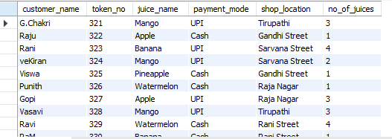

RESULT
- The juiceshopc table was successfully deleted and recreated. The customer records were inserted successfully, and the records were displayed using the SELECT command.

